
Lesson 7: On the Move
Godot Engine
VIDEO GAME CREATION
This week: enemies stop standing still. Your job is to make every enemy advance slowly toward the player, and clean up any that reach the bottom of the screen without being shot.
Open your own [YourName]Game project from Lesson 6 - don't start a new one.
Tip: no new assets this week - this is a logic-only lesson.

Setup
- Open your [YourName]Game project from Lesson 6.

Level 1 - Minimal (MVP)
Every enemy moves slowly downward, toward the player, instead of sitting still. An enemy that reaches the bottom of the screen unshot is removed - and does NOT count toward your win condition, since it escaped rather than being defeated.
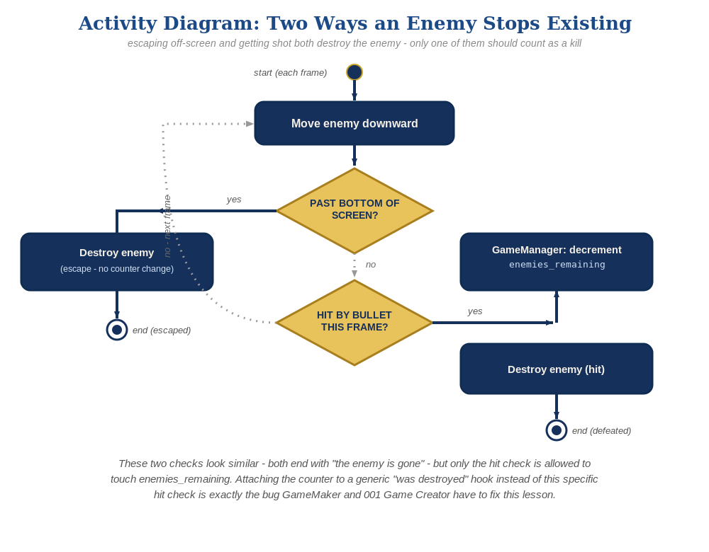
The general escape-vs-hit distinction behind this week's exercise - the same shape in every engine, whatever the exact code or blocks look like.
- In enemy.tscn's script, add var enemy_speed := 60.0 near the top.
- Add a _process(delta) function that moves the enemy downward and frees it (without emitting destroyed) if it goes past the bottom of the screen (code below).
- Run the scene and let the enemies drift downward - shooting one should still work exactly as before, and letting one reach the bottom unshot should just remove it, with no "You Win!" message.
# enemy.tscn's script - add near the top and as a new function:
var enemy_speed := 60.0
func _process(delta):
position.y += enemy_speed * delta
if position.y > 700:
queue_free()

Level 2 - Complete (Alpha/Beta)
A moving enemy can still be shot and destroyed correctly, and an enemy that escapes off the bottom never triggers "You Win!" by accident.
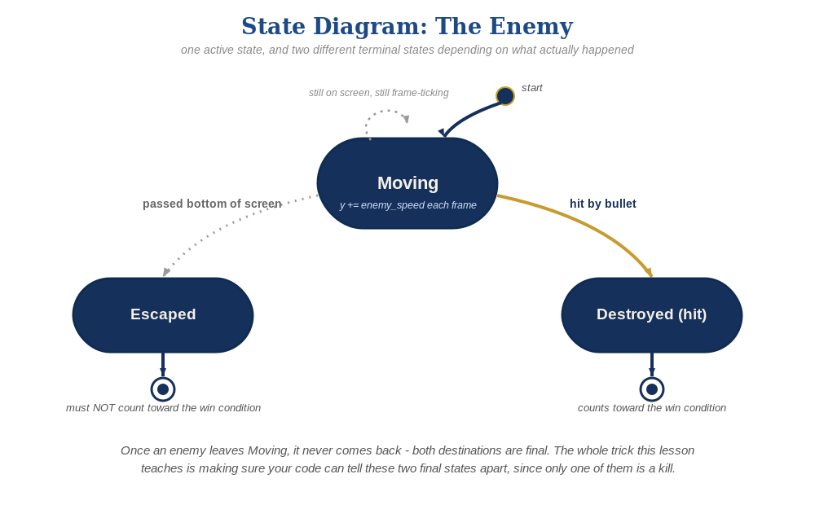
The enemy's two possible endings this week - only one of them should count as a kill.
- Shoot a moving enemy to confirm the Hitbox's area_entered collision still works correctly while it's in motion.
- Let at least one enemy escape off the bottom unshot, and confirm "You Win!" does NOT appear - only the destroyed signal (emitted exclusively from _on_hitbox_area_entered) can ever decrement enemies_remaining, since the main scene connects that signal directly to $GameManager.on_enemy_destroyed().

Level 3 - Refined (Ready to Publish) - pick any that interest you
- Visual: give each enemy a slightly randomized enemy_speed at spawn time (e.g. randf_range(50.0, 80.0) set on the instance right after instantiate()) so they don't all move in perfect lockstep.
- Structure: keep _process()'s escape-cleanup call as a plain queue_free() only - never let it call destroyed.emit(), which is reserved exclusively for _on_hitbox_area_entered().

If Something's Wrong
- Enemies don't move at all: confirm _process(delta) is spelled exactly right (case-sensitive) and is a new function, not accidentally merged into _ready().
- "You Win!" appears even when enemies escaped unshot: confirm _process()'s escape cleanup calls queue_free() only, with no destroyed.emit() anywhere near it.
- Enemies move but never disappear at the bottom: confirm the position.y > 700 threshold actually matches your project's visible screen height - adjust the number if your window size differs.

Want More?
Student Resource List > Godot section, or docs.godotengine.org

